**Employee Name: Balaji Srinivasan**

**Employee Id: 673817**

**PART-1 Automation**

**Step1: Cloud Formation**

Creating VPC with one public subnet and one private subnet, routing table and internet gateways

Creation of stack with template:

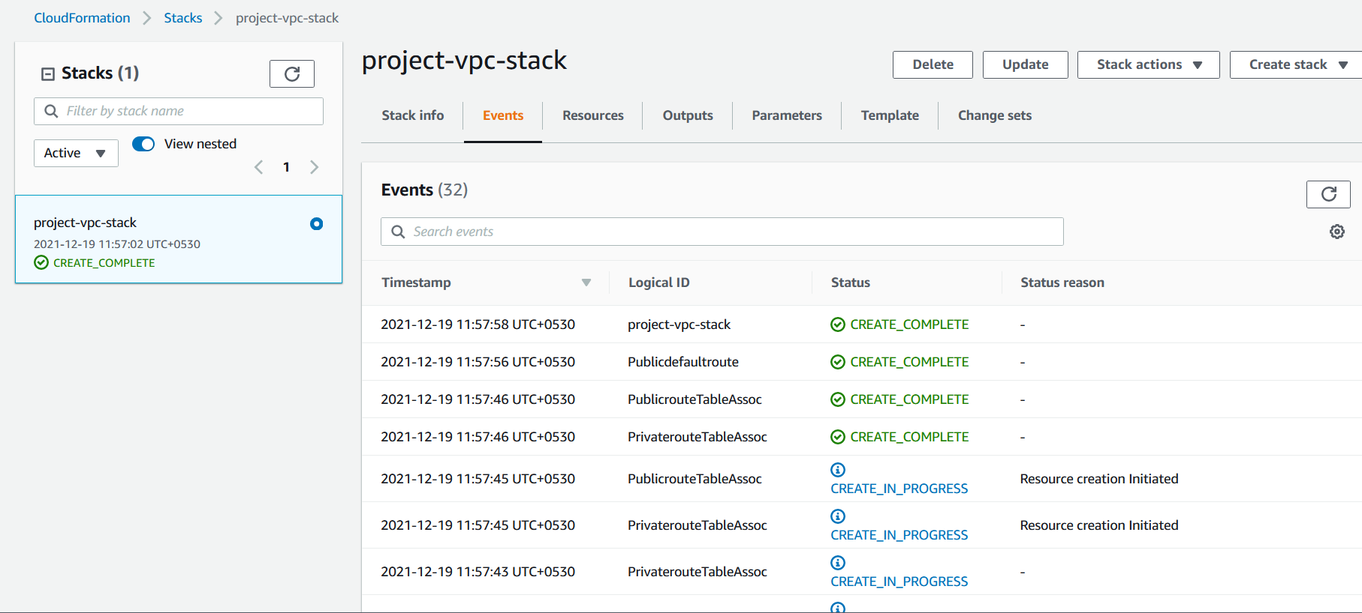

VPC:

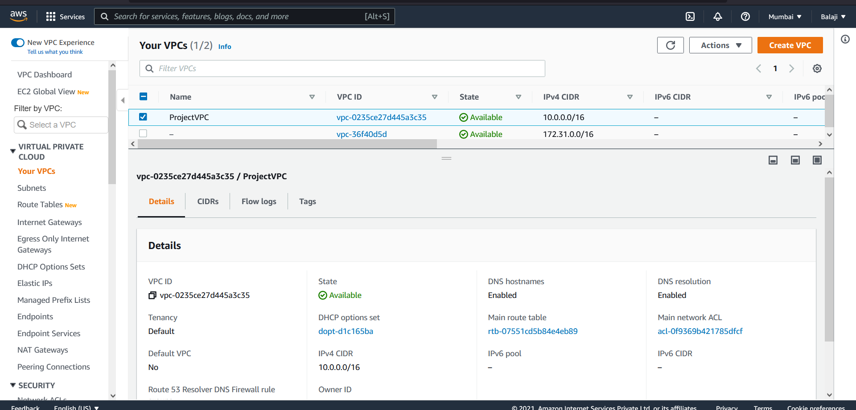

Public Subnet:

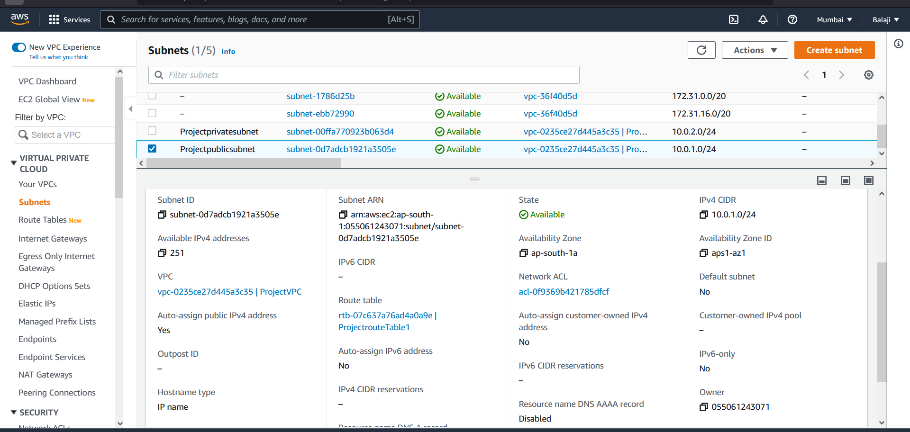

Private Subnet:

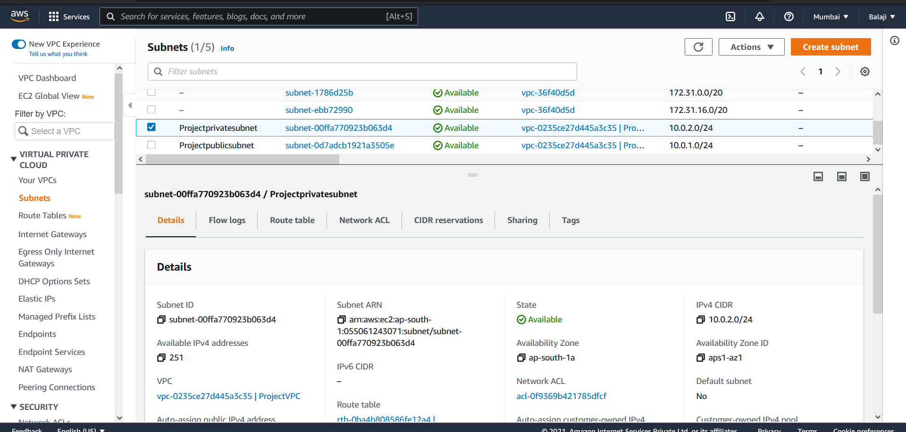

Routing Table:

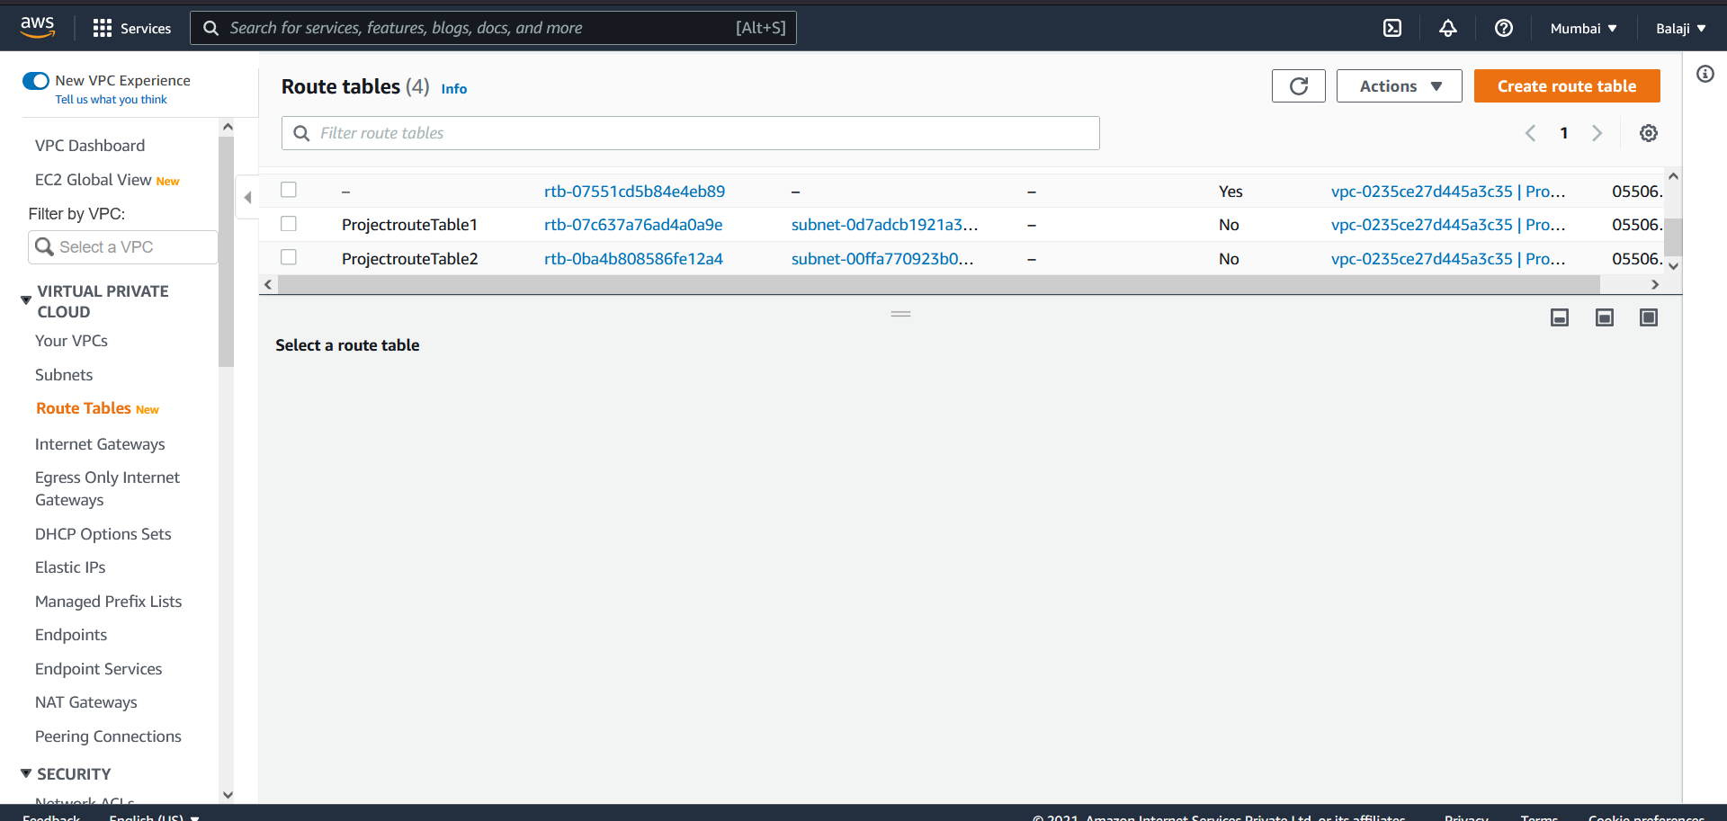

Internet Gateway:

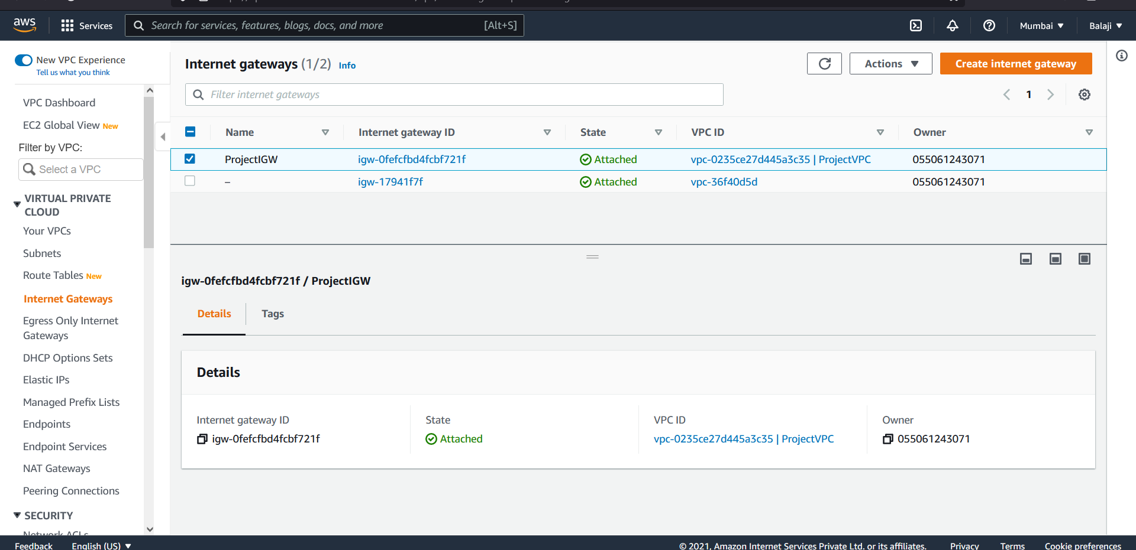

**Step2: Terraform**

1. Create application infrastructure using auto scaling group along with Layer 4 load balancer

Terraform output:

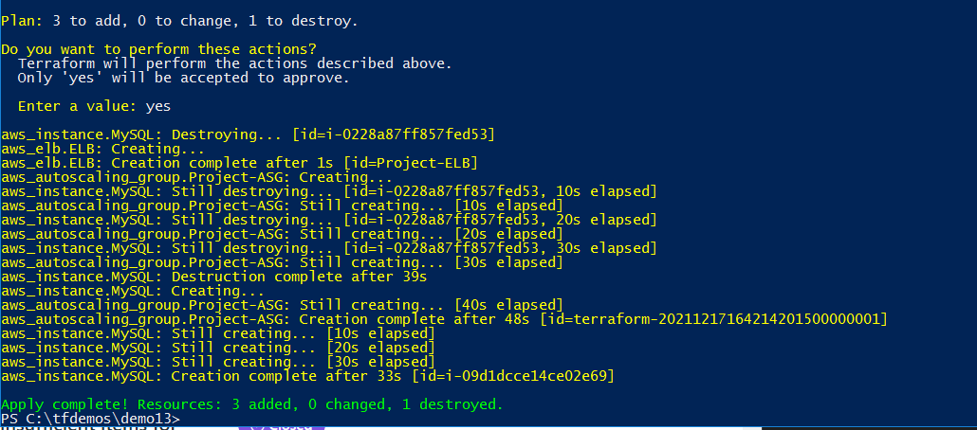

Security Groups:

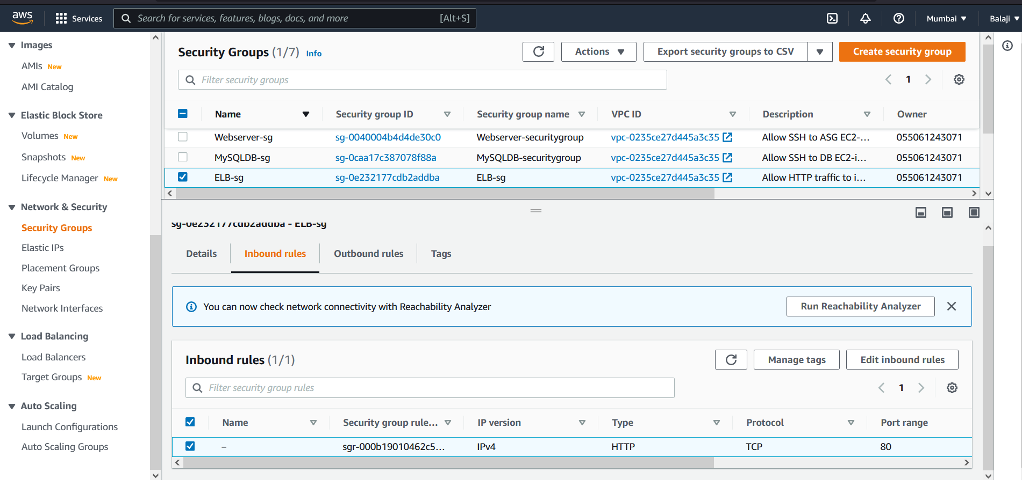

Load Balancer:

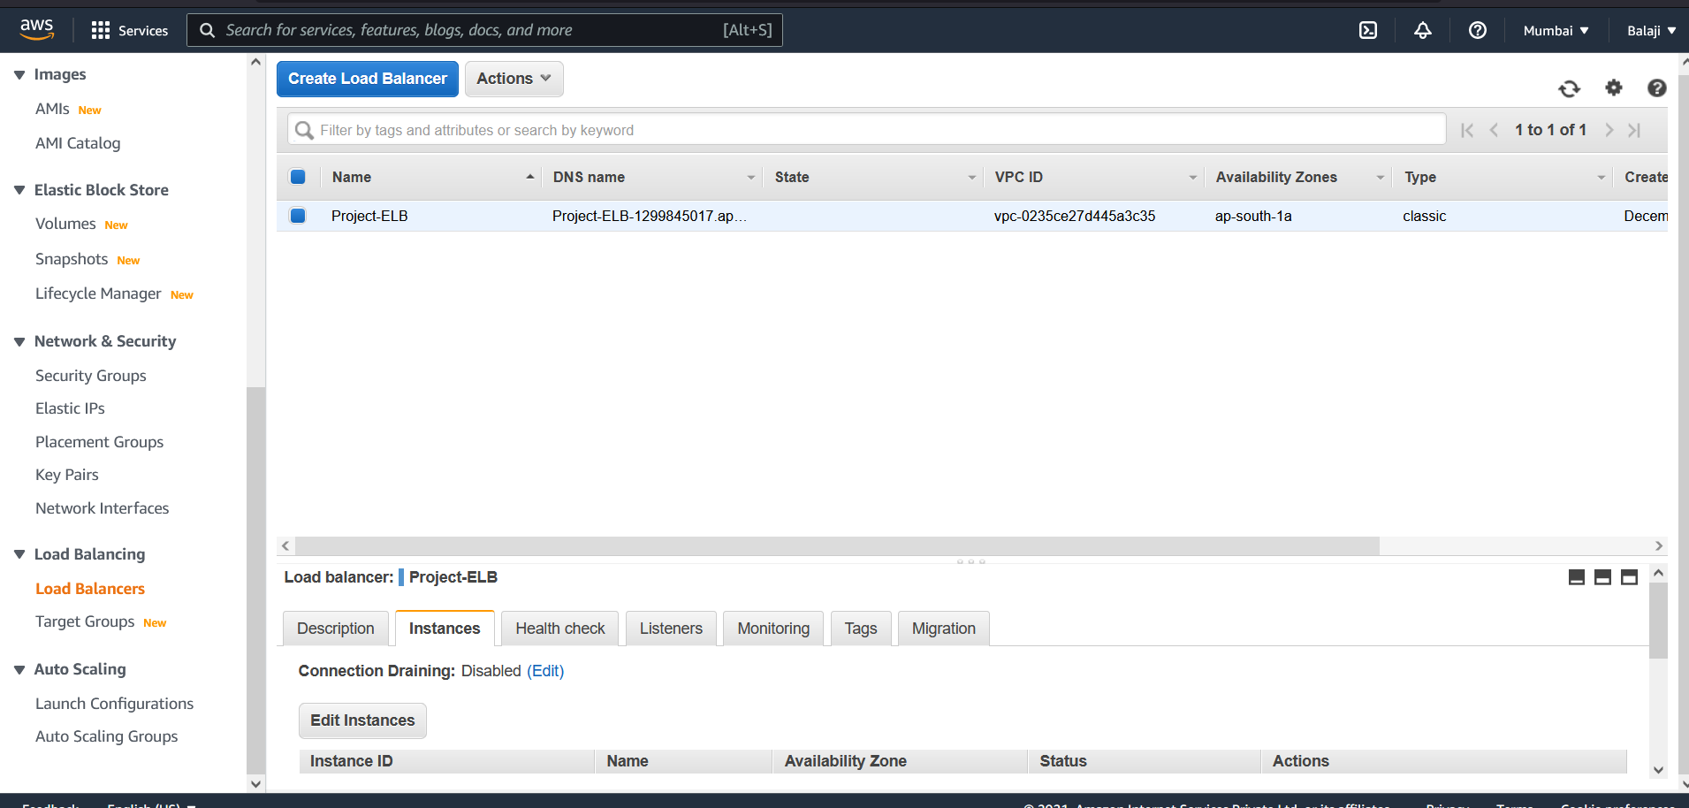

Launch Configuration:

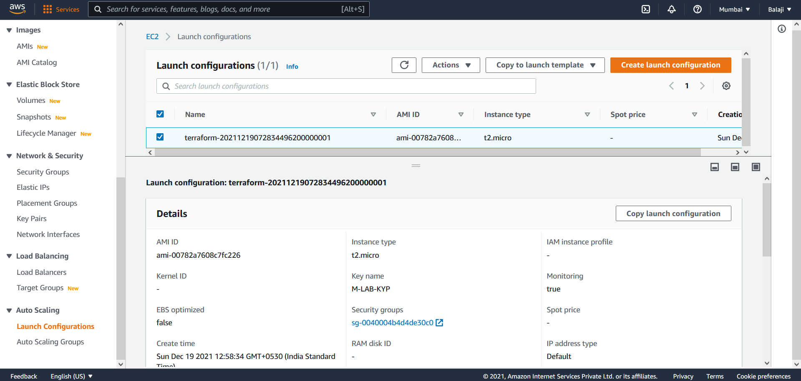

Auto scaling group:

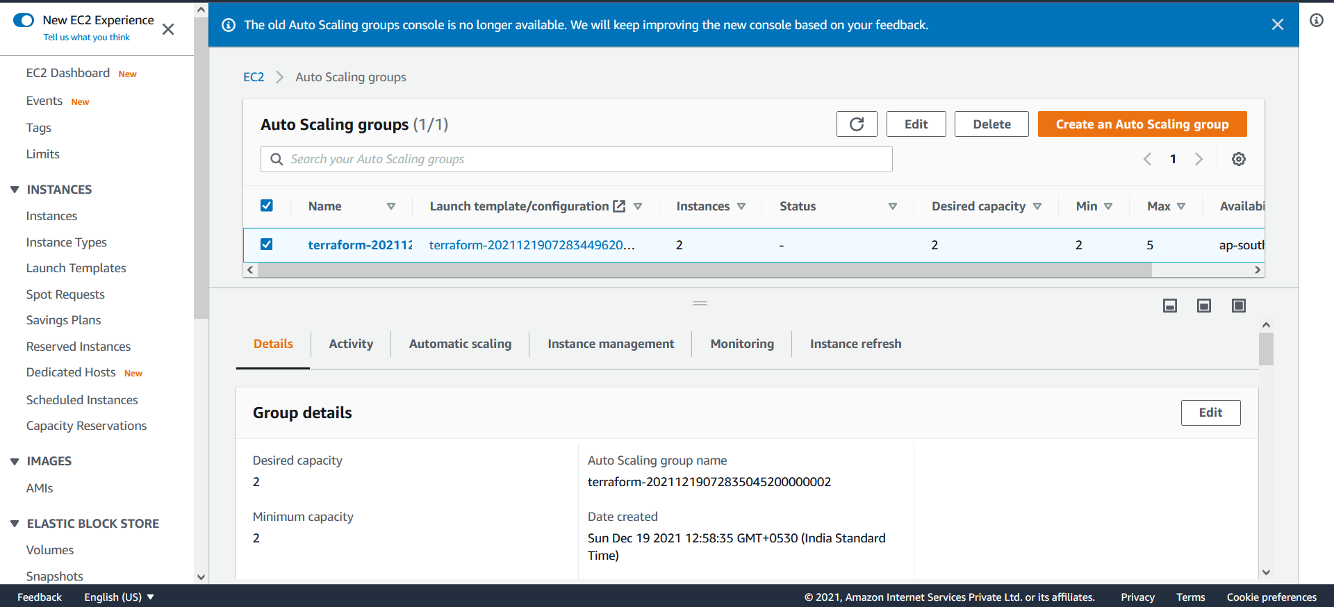

Web cluster Instances:

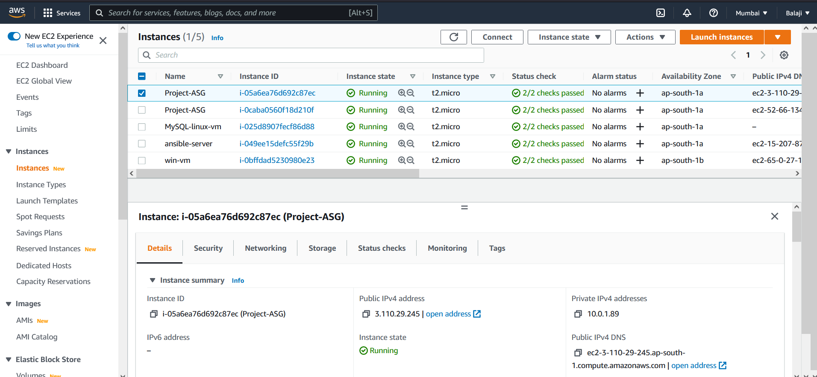

1. Creating EC2 instances with ubuntu in private subnet.

MySQL Instance:

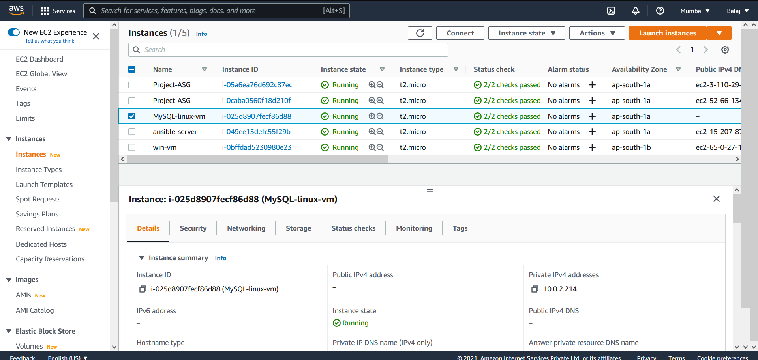

**Step3: Ansible**

Install Apache server on top of ASG EC2 instances and install MySQL DB in private instance

Configured ASG EC2 instance and private instance as remote nodes in ansible server and check ping test:

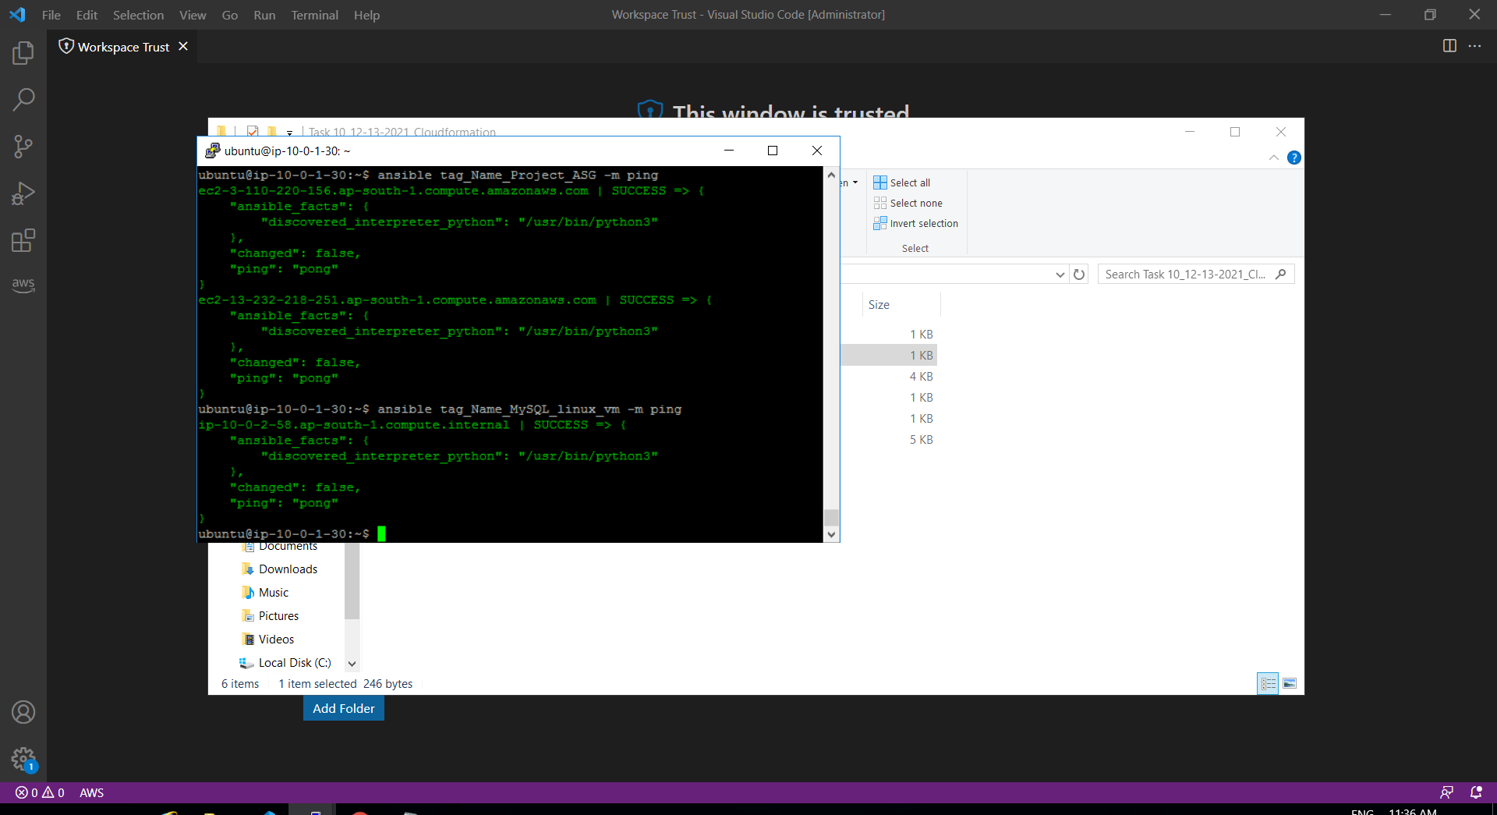

Installed Apache server successfully on ASG instances:

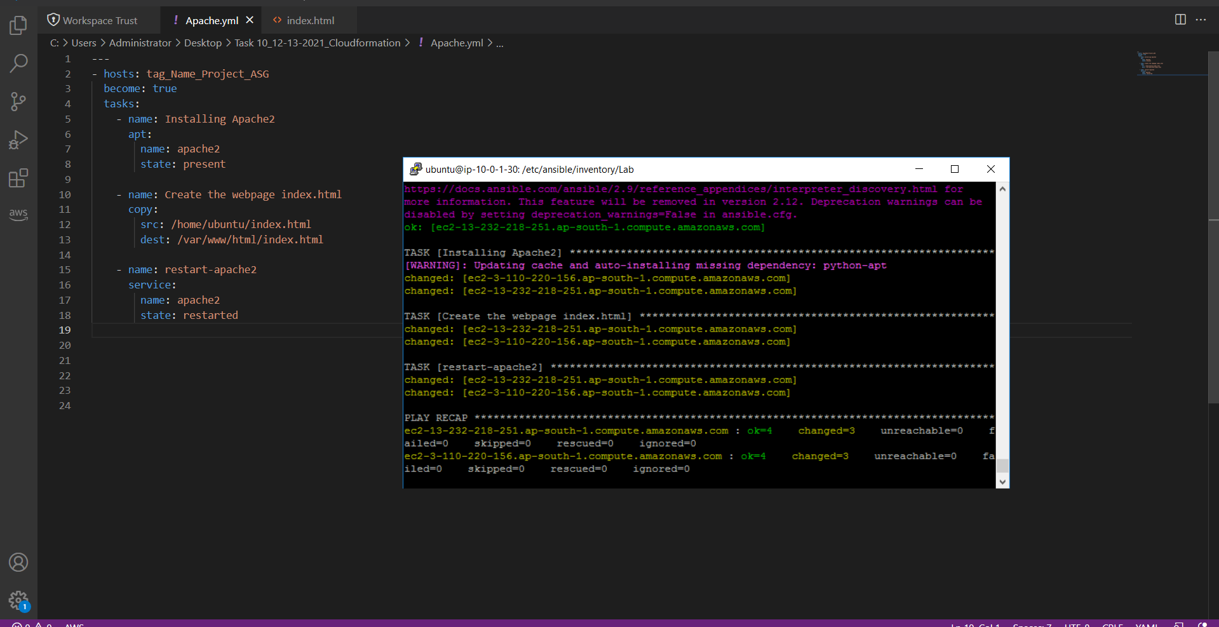

ASG 1st instance:

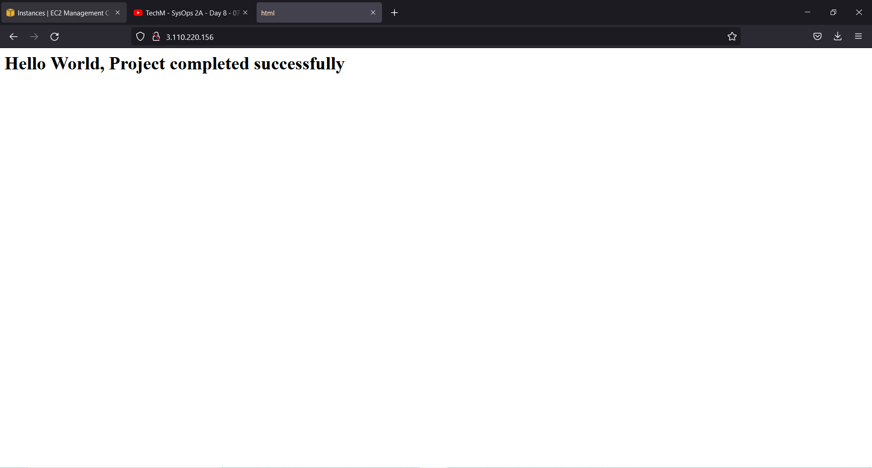

ASG 2nd instance:

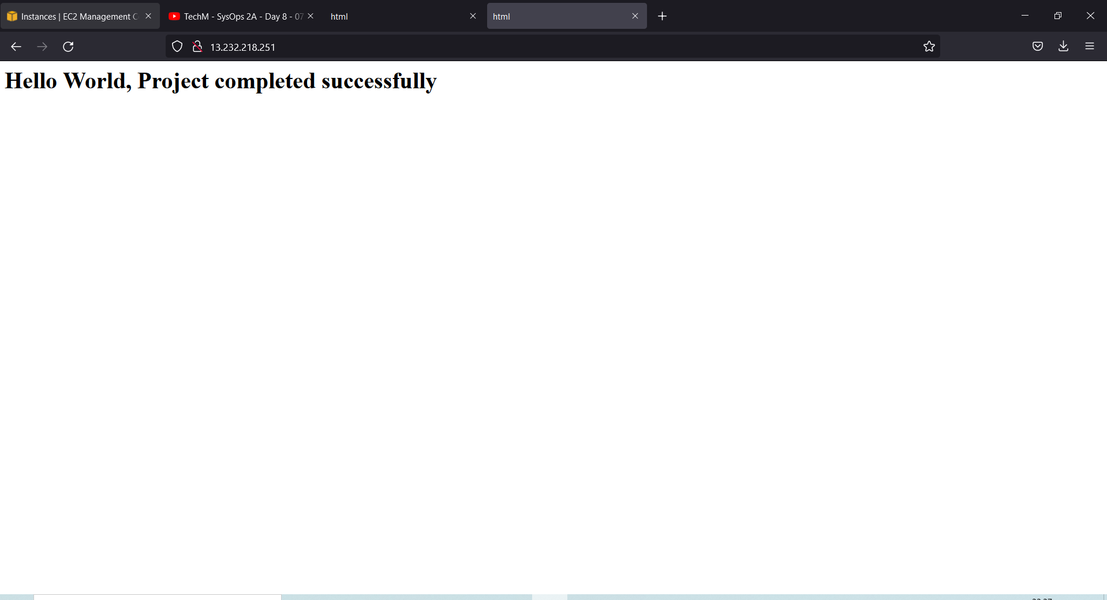

Install MySQL in private subnet EC2 instance

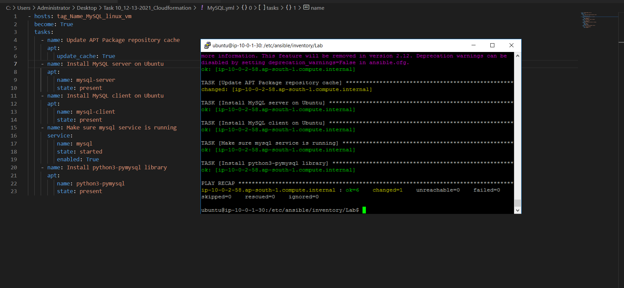

ssh into private subnet EC2 instance and login to MySQL server

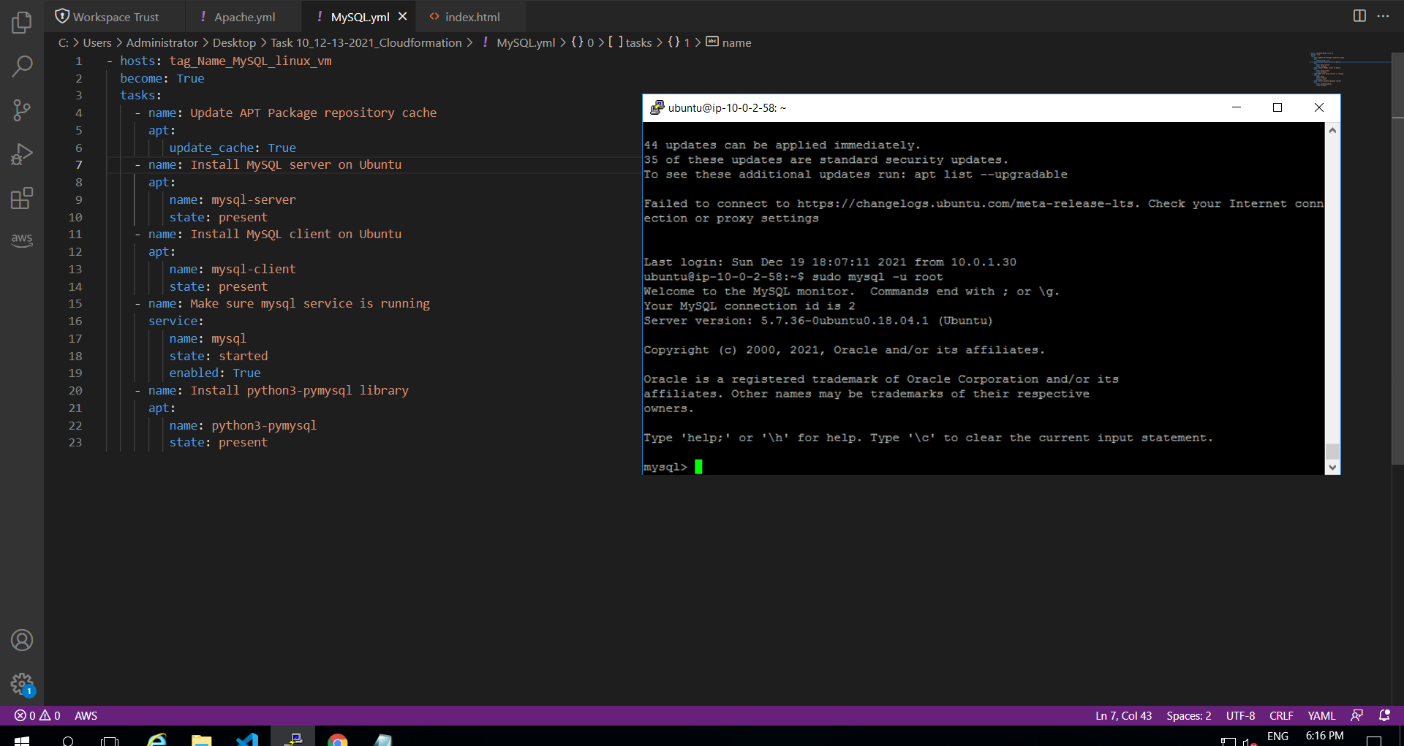

**PART-2 Secure Communication and Security Management for Application (Manual Configuration)**

Route53 Configuration for VPC internal communication:

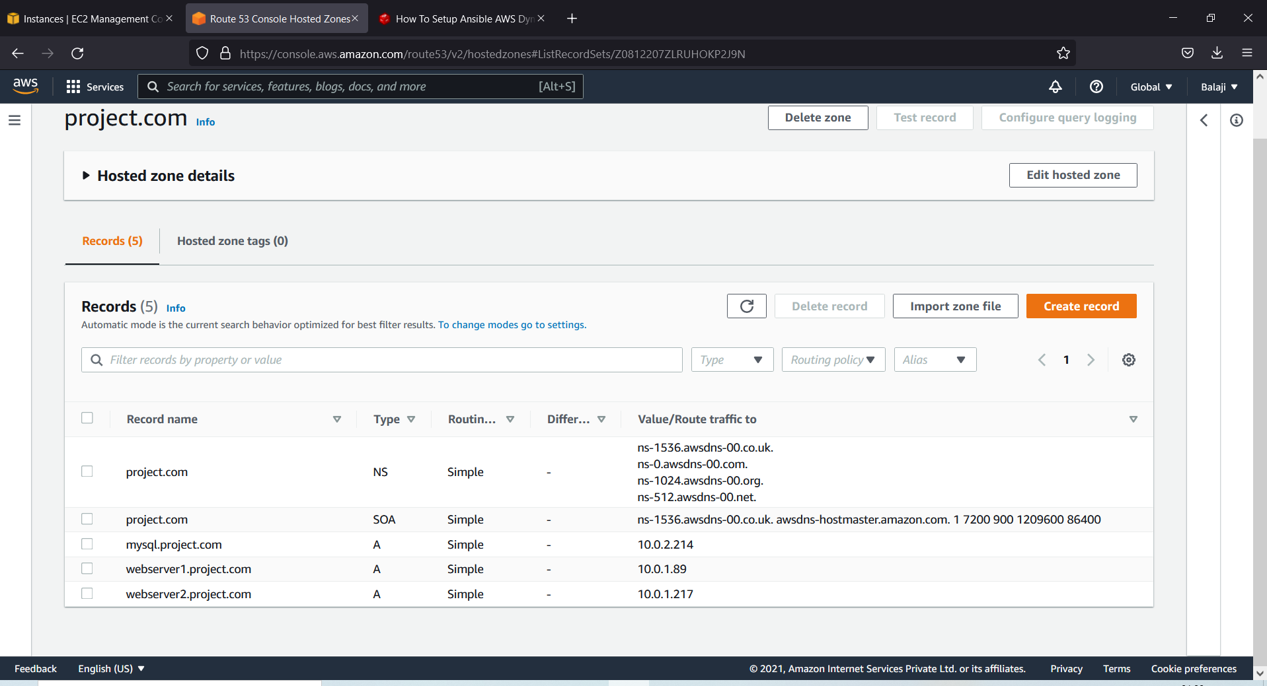

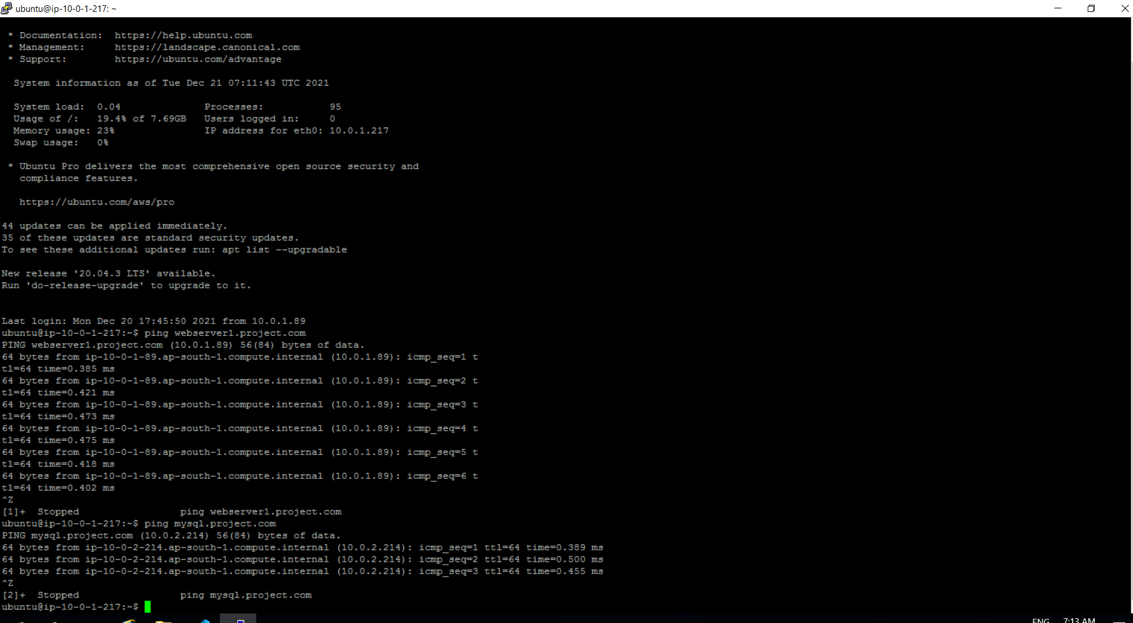

MySQL DB (EC2) should be accessible only from ASG (Webserver Cluster) Hint: Security Groups

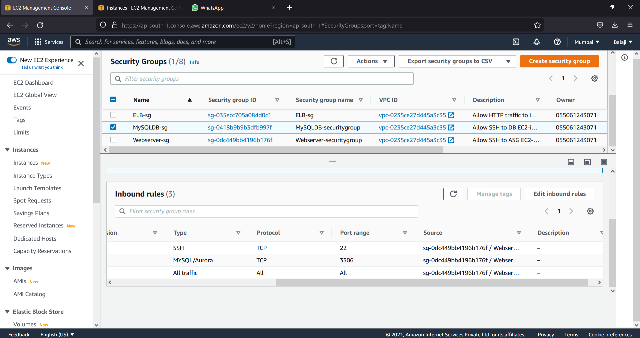

Create user to manage application infrastructure (VPC, Route53, EC2) Hint: IAM Policies

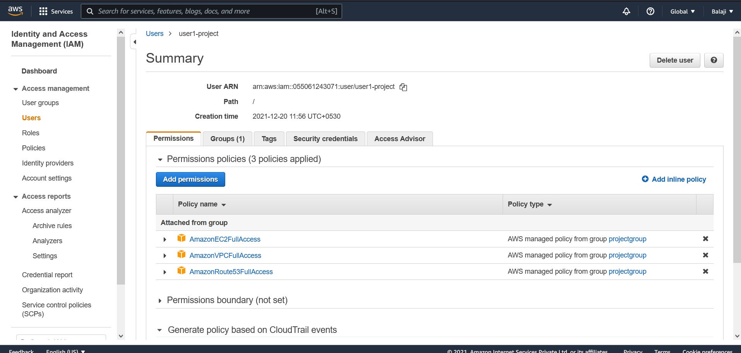

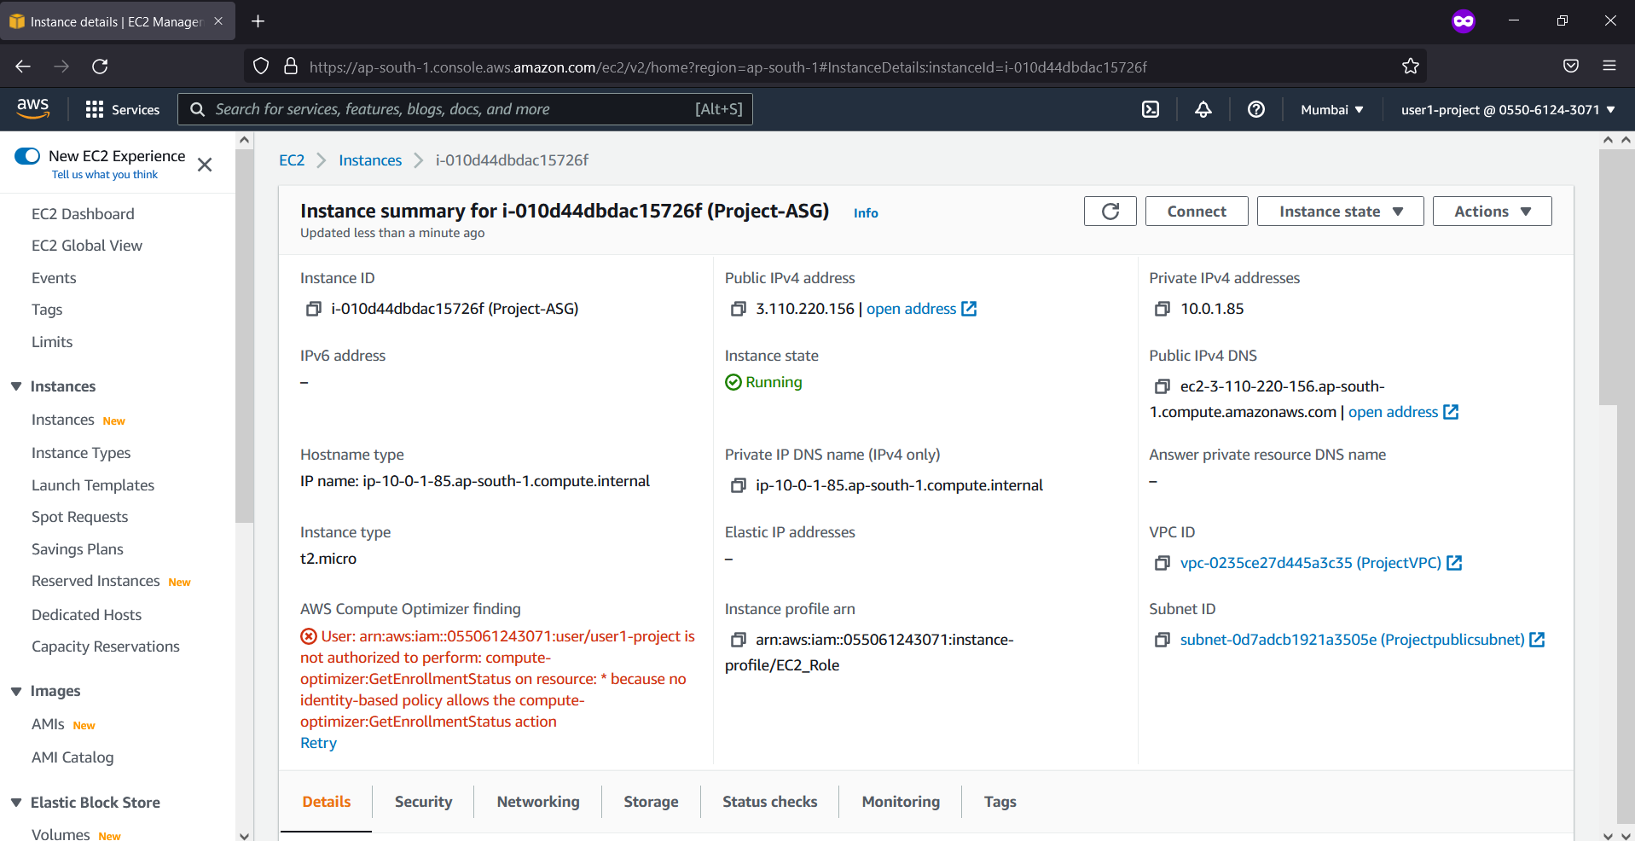

Create S3 Bucket to store log files:

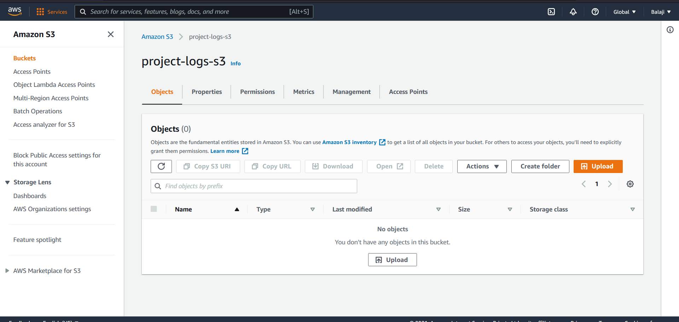

All EC2 instances should have permission to access S3 Hints: IAM Roles

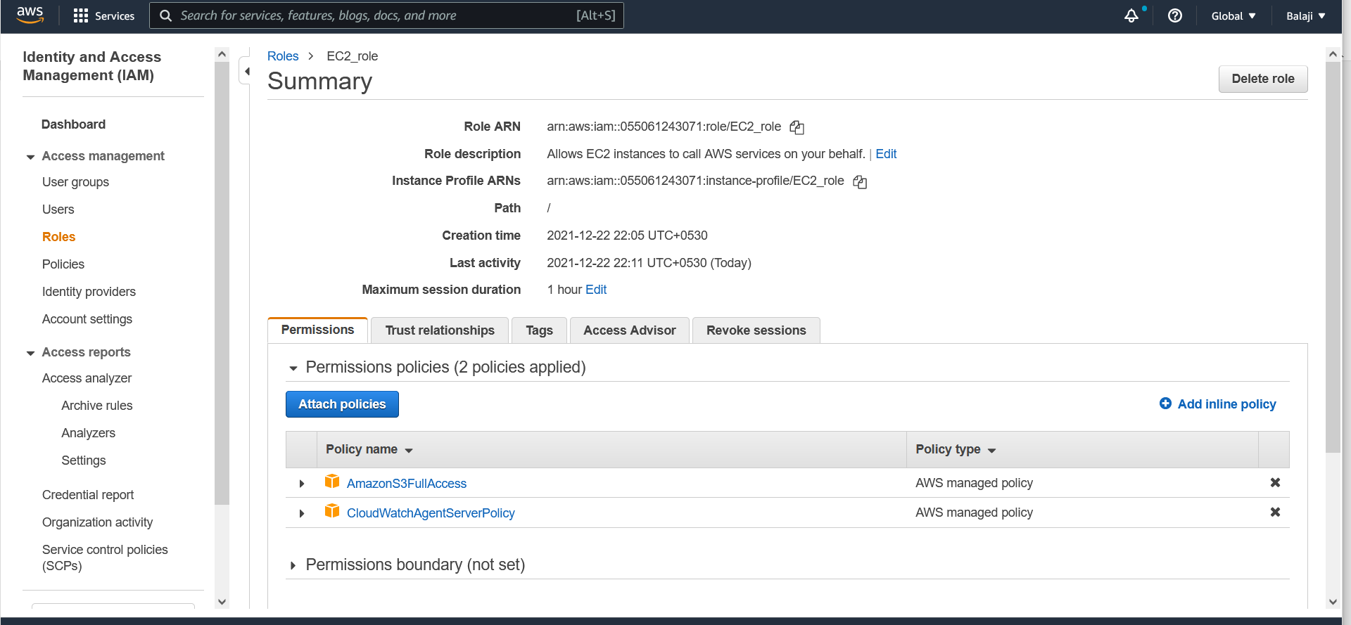

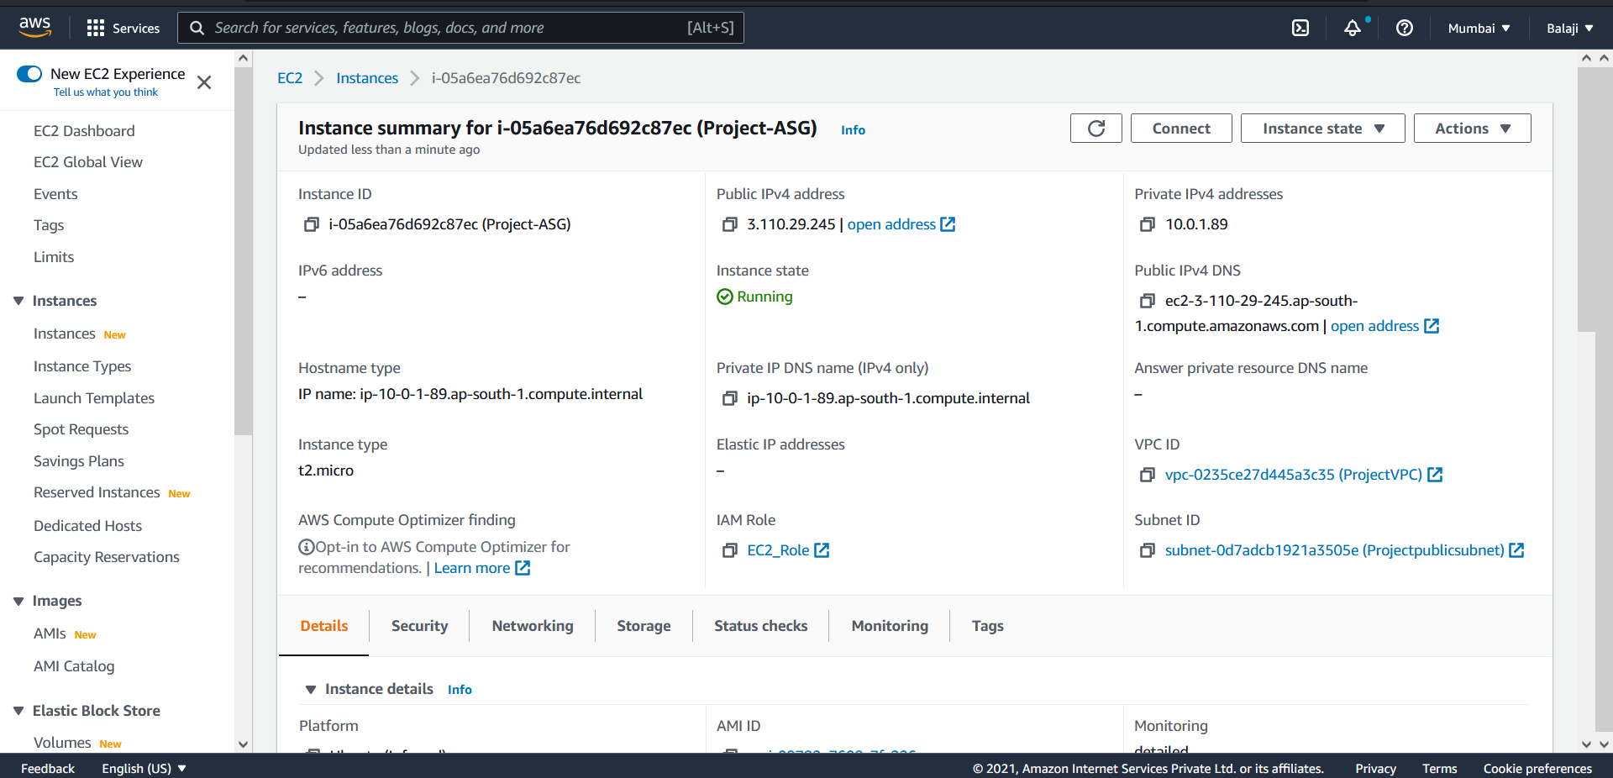

**PART-3 Monitoring App and App Infrastructure (Manual Configuration)**

**Create a CloudWatch Dashboard to monitor:**

